Supplementary Material

Generating a sub-nm-confined optical field in a nano-slit waveguiding mode

Liu Yang,a† Zhanke Zhou,a† Hao Wu,a Hongliang Dang,a Yuxin Yang,a Jiaxin Gao,a Xin Guo,a,b Pan Wang,a,b Limin Tonga,b,c,*

aZhejiang University, College of Optical Science and Engineering, New Cornerstone Science Laboratory, Interdisciplinary Center for Quantum Information, Hangzhou, China

bJiaxing Institute of Zhejiang University, Intelligent Optics & Photonics Research Center, Jiaxing, China

cShanxi University, Collaborative Innovation Center of Extreme Optics, Taiyuan, China

**\***Corresponding author**,** E-mail: [phytong@zju.edu.cn](mailto:phytong@zju.edu.cnuniversity.edu)

†These authors contributed equally to this work.

# 1 Numerical calculation

For studying the optical response of an all-dielectric structure, the classical electromagnetic theory is valid with a feature size down to 1 nm or even below.48 Thus, we use commercial software of Maxwell’s equations solver (Lumerical FDTD and COMSOL) to simulate mode evolutions and nano-slit modes in the CNP. In the waveguiding scheme, we use Lumerical FDTD to simulate the mode evolution in three dimensions. The fundamental TE modes of input waveguides are selected as input modes in the mode source module. To simulate the field around the areas of nano-slit with enough precision, and avoid an intolerable amount of computation in 3-D simulations, we mesh the area with a maximum size of 0.5 nm near the mode field monitors (10×10×5 nm) in three dimensions Lumerical FDTD. In the rest area, we use a default conformal mesh.

Typically, the interface between the nanowire and the air exhibits 1-nm-level surface roughness on the side edge (Fig. S1), forming a gradual transition of the refractive index *n* from the perfect CdS crystal region inside the nanowire (i.e., *n* = 2.37 at 650-nm wavelength) to the air (or vacuum) outside the nanowire (i.e., *n* = 1.0). Therefore, to be more precise, in the 2-D Comsol simulation, around the 1-nm-thickness transitional region on the nanowire surface, we use a linearly changing index profile (instead of a step-index profile) from *n* of the bulk material (e.g., *n*CdS) to the *n* of the environment (e.g., *n*air). Meanwhile, the radius of the corner (*r*) is about 5 nm.34 In addition, another previously reported surface model assumes that the surface roughness is sine deformed.55,56 We compare the simulation using two surface roughness models at the 1-nm-thickness transitional region: linear approximation and cosine approximation, with results shown in Fig. S2. The field confinement and the peak-to-background ratio obtained by the two models are almost the same, indicating that using the linear index approximation in the simulation is reasonable. Therefore, in the simulation, from the cross-sectional view, both sides of the nano-slit are assumed to have 5-nm-radius edges with 1-nm-thickness index transition regions. The mesh around the area of the slit is set as free triangular with a maximum element size of 0.1 nm in Comsol. The refractive index of CdS and CdTe is obtained from Ref. 37 and Ref.50, respectively.

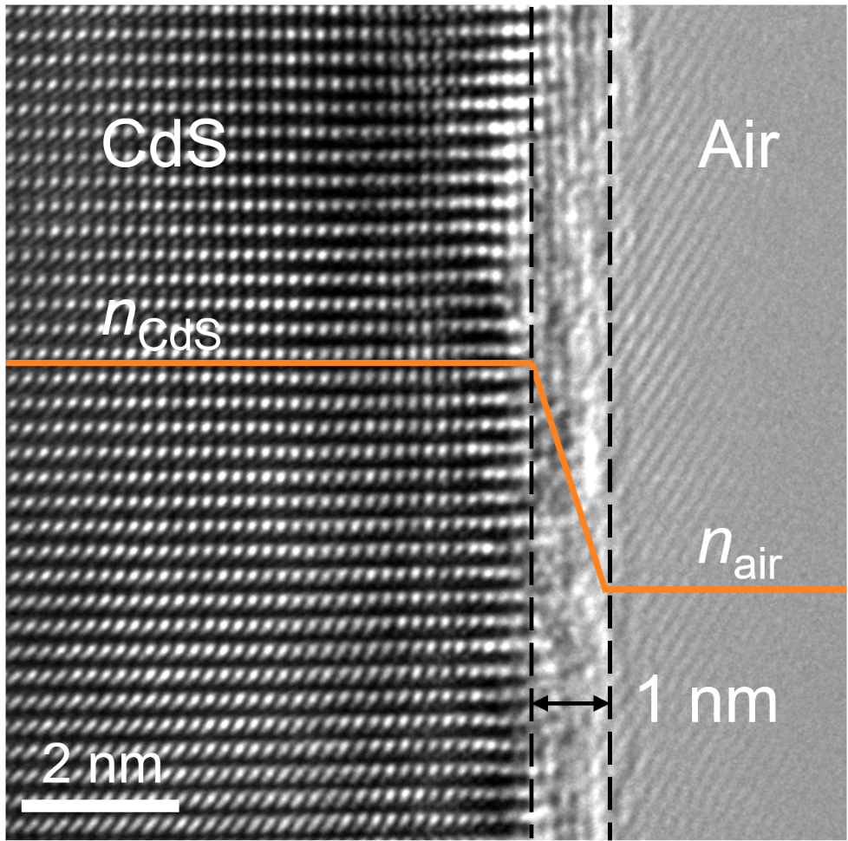

Fig. S1 Typical high-resolution transmission electron microscopy image of the edge of a CdS nanowire.



Fig. S2 (a) Refractive index profile of linear approximation in the slit of a CdS CNP. (b) *λ*-dependent FWHM of the field intensity of the TE0-like mode along the *x*-axis (blue line) and *y*-axis (orange line) in a linear approximation. (c) *λ*-dependent peak-to-background ratio *RP1*/*B* (blue line) and *RP*2/*B* (orange line) of the TE0-like nano-slit mode in a linear approximation. (d) Refractive index profile of cosine approximation in the slit of a CdS CNP. (e) *λ*-dependent FWHM of the field intensity of the TE0-like mode along the *x*-axis (blue line) and *y*-axis (orange line) in a cosine approximation. (f) *λ*-dependent peak-to-background ratio *RP*1/*B* (blue line) and *RP*2/*B* (orange line) of the TE0-like nano-slit mode in a cosine approximation. The parameters of CdS CNP in Fig. S2 are set as *d*=140 nm, *w*=1 nm, and *r*= 5nm.

# 2 Definition of the mode purity

In the CNP mode evolution, the final optical field can be decomposed by a set of eigenmodes of the CNP waveguide, as follow:

 (S1)

 and represents the electric field of the final optical field and the *m*-order eigenmodes, respectively. *am* represents the complex coefficient of corresponding modes. A similar definition is applied to magnetic field componentsin the optical field. Since all eigenmodes () are orthogonal, we define：

 (S2)

 (S3)

*Pm* represents the power of the *m*-order mode. The mode purity of the nano-slit mode represents the ratio of the energy occupied by the nano-slit mode (i.e., TE0-like mode) to the total power of the final optical field, defined as follows:

 (S4)

and  represents the electric and magnetic fields of the nano-slit eigenmode, respectively. *P* represents the total power of the final optical field.

# 3 Lowest-order modes in a nanowire

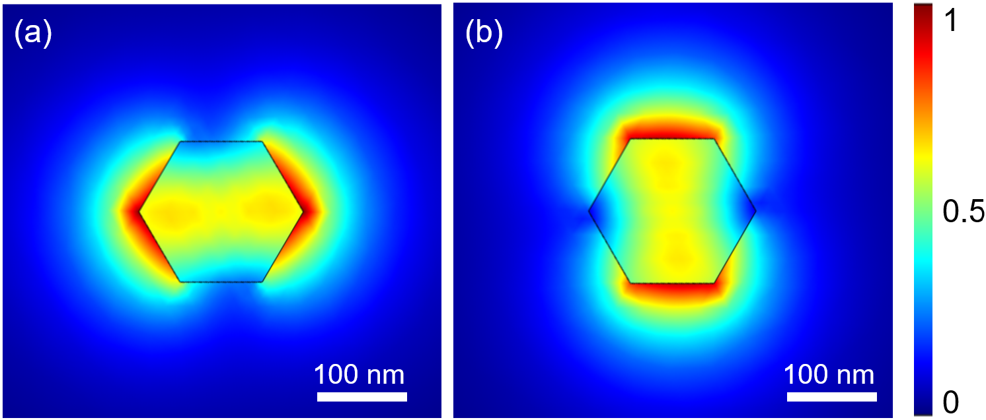

Fig. S3 Normalized electric field distribution of TE0-like mode (a) and TM0-like mode (b) in a 180-nm-diameter CdS nanowire at 550-nm wavelength.

# 4 Broadband *n*eff-matching of the nano-slit mode and the HE11 mode

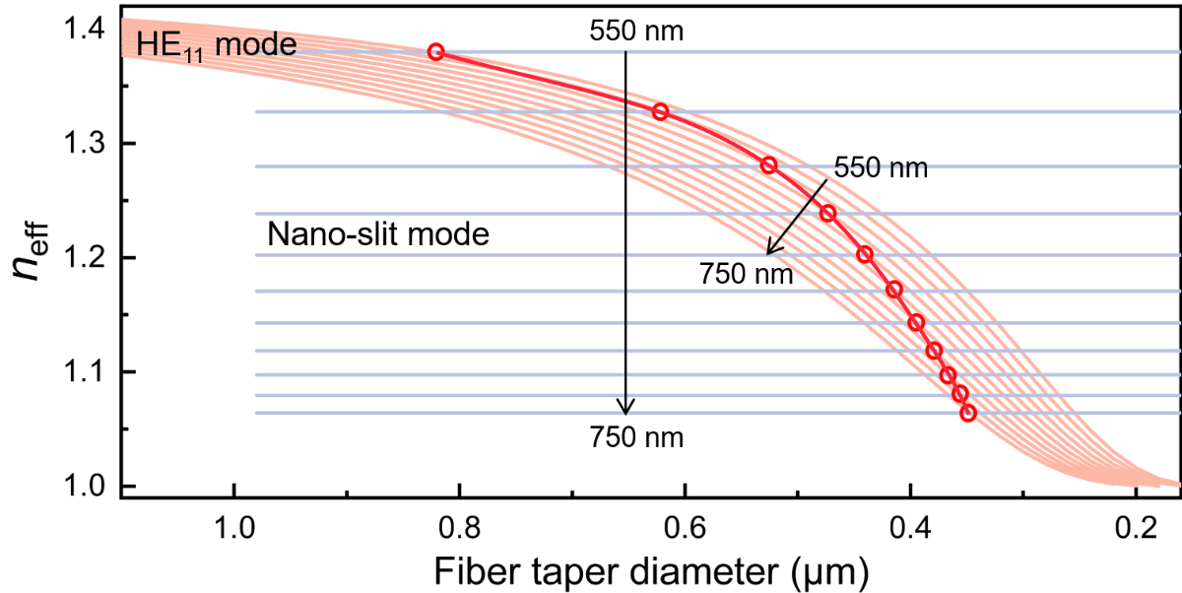

Fig. S4 *n*eff of the HE11 mode of the fiber taper and the nano-slit TE0-like mode of the CNP in Fig. 3. The blue and pink lines indicate the nano-slit mode and the HE11 mode at a corresponding wavelength from 550 to 750 nm with a wavelength-step of 20 nm, respectively. The intersected red circles indicate neff-matching points of the nano-slit mode and the HE11 mode at the same wavelength and the red line is a smooth connection of these points.

# 5 On-chip CNP waveguiding scheme

For the on-chip case, we propose a side-by-side coupling scheme to launch a CNP supported on a SiN chip. As shown in Fig. S5(a), a tapered planar waveguide with a tapering angle of 2 degrees is used to parallelly contact one side of the CNP, and evanescently coupled light into the CNP over a certain length. Since an on-chip waveguide (either the SiN waveguide or the CNP) usually requires a relatively high *n*eff to avoid the leakage of waveguided light into the substrate, the nanowire diameter of the CNP is assumed to be 180 nm. The input mode is assumed to be the fundamental TE0 mode of the tapered planar waveguide [Fig. S5(b)]. When it propagates through the coupling area, the input light starts to couple into the CNP [Fig. S5(c)] and gradually evolutes into the nano-slit mode with increasing coupling length [Fig. S5(d)], and finally output from the right-most end of the CNP [Fig. S5(e)]. Similarly, the coupling length and geometry of the tapered planar waveguide are optimized for maximizing the efficiency of exciting the nano-slit mode in the CNP within the *n*eff-matching area [Fig. S5(f)]).

Compared with the freestanding-CNP case (using 1.0-refractive-index air as the surrounding medium), the on-chip CNP must maintain a *n*eff (which decreases with increasing wavelength) higher than that of the SiO2 substrate (*n*=1.45), which shortens the available long-wavelength edge to 650 nm [Fig. S5(g)]. Also, the on-chip coupling structure is much less symmetric, leading to less isolation of cross-coupling between orthogonal polarizations and consequently a relatively lower coupling efficiency and mode purity of the nano-slit mode [Fig. S5(g)], i.e., a coupling efficiency higher than 55% with a maximum of about 85%, and a mode purity higher than 85% within the spectral range of 550 to 650 nm.

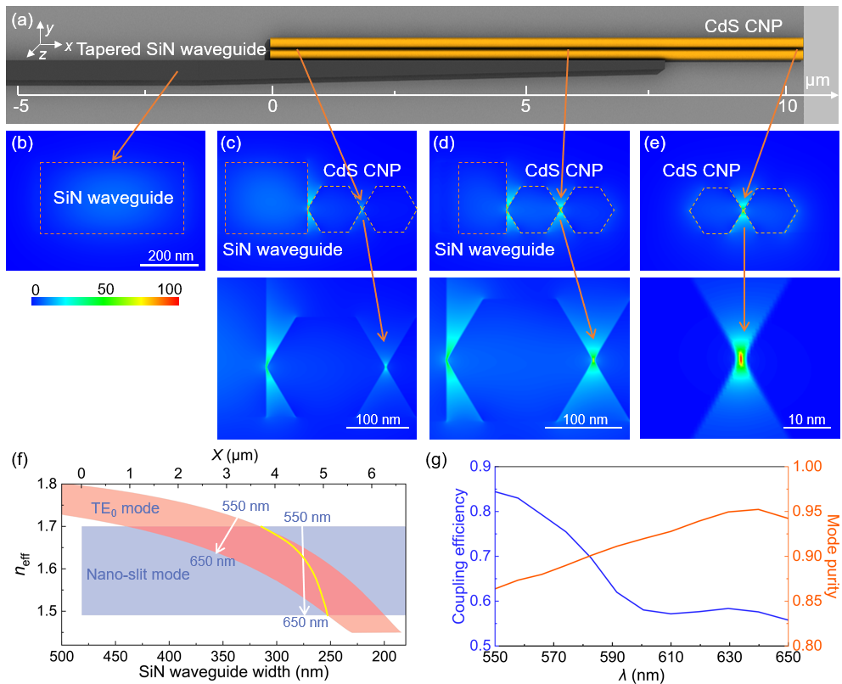

Fig. S5 Mode evolution in an on-chip CdS CNP waveguide. (a) Schematic diagram of the coupling structure. A horizontal coordinate indicates the waveguide length originated from the left end of the CNP. (b)-(e) Field intensity distribution in *y*-*z* planes (cross-sectional planes) at corresponding *x* positions marked by yellow arrows. The simulation is carried out with a nanowire diameter of 180 nm and a SiN-waveguide-taper angle of 2 degrees at 620-nm wavelength. The bottom panels in (c)-(d) are close-up views of the electric field pointed by yellow arrows. The scale bar in (b) applies to the upper panels in (b)-(e). (f) *n*eff of the TE0 mode in the SiN waveguide and the TE0-like nano-slit mode in the CNP within the spectral range of 550-650 nm. The blue and pink areas indicate the nano-slit mode and the TE0 mode, respectively. The intersecting red area is the *n*eff-matching areaof the two modes within the spectral range of 550-650 nm, and the solid yellow line represents the matched *n*eff of the two modes at the same wavelength, with respect to the SiN waveguide width. (g) Broadband coupling efficiency and mode purity of the TE0-like nano-slit mode.

# 6 TE0-like modes in a CdS CNP with varying slit widths and vertex radii

In the manuscript, all slit widths are set as 1 nm in our simulation. Here, we calculate the TE0-like mode with different slit widths in a CdS CNP at 550-nm wavelength, with results given in Fig. S6. With increasing slit widths, the FWHM in both the *x*-axis and *y*-axis almost linearly increases (Fig. S6(a)), while the peak-to-background ratio of the central peak (*RP*1/*B*) decreases (Fig. S6(b)) due to the weakened max intensity in the central slit. Interestingly, the peak-to-background ratio of the second height peak (*RP*2/*B*) experiences a slight rise with a larger slit width (Fig. S6(b) and (c)-(g)).



Fig. S6 Slit-width-dependent TE0-like modes in a CdS CNP at 550-nm wavelength. (a) FWHM of the field intensity of the TE0-like mode along the *x*-axis (blue line) and *y*-axis (orange line). (b) Peak-to-background ratio *RP*1/*B* (blue line) and *RP*2/*B* (orange line) of the TE0-like mode. (c)-(g) Field intensity distribution along the *x*-axis with *w* of (c)2 nm, (d) 5 nm, (e) 10 nm, (f) 20 nm, and (g) 50 nm, respectively. The parameters of the CdS CNP in Fig. S6 are set as *d*=140 nm and *r*=5 nm.

Meanwhile, we calculate the TE0-like mode with different corner radii in a CdS CNP at 550-nm wavelength. In the manuscript, we set the radius of nanowire corners as 5 nm, obtained from typical HR-TEM pictures of nanowire cross-sections. The results with varying corner radii are given in Fig. S7. It shows that, with increasing corner radii, the FWHM of the field intensity along the *x*-axis is almost unchanged maintaining at a 0.3-nm level (Fig. S7(a)), mainly due to the small change in the distribution of the refractive index along the *x*-axis. Instead, the field confinement along the *y*-axis is weakened with a larger corner radius (Fig. S7(a) and (c)-(f)). The peak-to-background ratio of both central and second height peaks is also decreased with increasing corner radii (Fig. S7(b)).



Fig. S7 Corner-radius-dependent TE0-like modes in a CdS CNP at 550-nm wavelength. (a) FWHM of the field intensity of the TE0-like mode along the *x*-axis (blue line) and *y*-axis (orange line). (b) Peak-to-background ratio *RP*1/*B* (blue line) and *RP*2/*B* (orange line) of the TE0-like mode. (c)-(e) Normalized cross-sectional field intensity distribution of the TE0-like mode with *r* of (c) 1 nm, (d) 2 nm, (e) 5 nm, and (f) 10 nm, respectively. The parameters of the CdS CNP in Fig. S7 are set as *d*=140 nm and *w*=1 nm.

# 7 Central peak power in the nano-slit mode

As the total mode is still diffraction-limited, the central peak occupying an ultra-small area concentrates a very small fraction of the total mode power (Fig. S8). Compared with the MIR spectral range, the central peak has more fractional power in the visible spectral range, due to a larger proportion of the area (Fig. S8(a) and (b)). In addition, we calculate the fractional power in a CdS CNP at 550-nm wavelength with varying *w* and *r*, with results shown in Fig. S8(c). It shows clearly that, more fractional power is confined in the central peak with increasing *w*, while the central power remains almost unchanged with *r* changing from 1 to 10 nm.



Fig. S8 Fractional power in the central confined field over the total mode power in a CdS CNP waveguide. (a) and (b) Diameter-dependent fraction power in the visible (a) and MIR (b) spectral ranges. The parameters of the CdS CNP are set as *w*=1 nm and *r*= 5nm. (c) Dependece of the fractional power on *w* and *r* at 550-nm wavelength. The parameter of the CdS CNP is set as *d*=140 nm.